**Moderate to Severe Evaluation**

Sample_id :**KGKPRD(Cat)**

Link:<https://app.animalbiome.com/pet/assessment/report/075423e9-9aa3-4d3f-879e-e601860f4f84>

Cats and dogs:

Any two of the following:

(

High Red Flag Megamonas OR (**Passed**)

High Red Flag Sutterella OR (failed)

High Red Flag Collinsella OR (failed)

Low Red Flag Bacteroides OR (failed)

Low Red Flag Blautia (failed)

);

OR

Cats:

11 or more yellow flags;(**Passed**)

OR 9 or more red flags;(**Passed**)

High Red sutterella,High red collinsella failed.

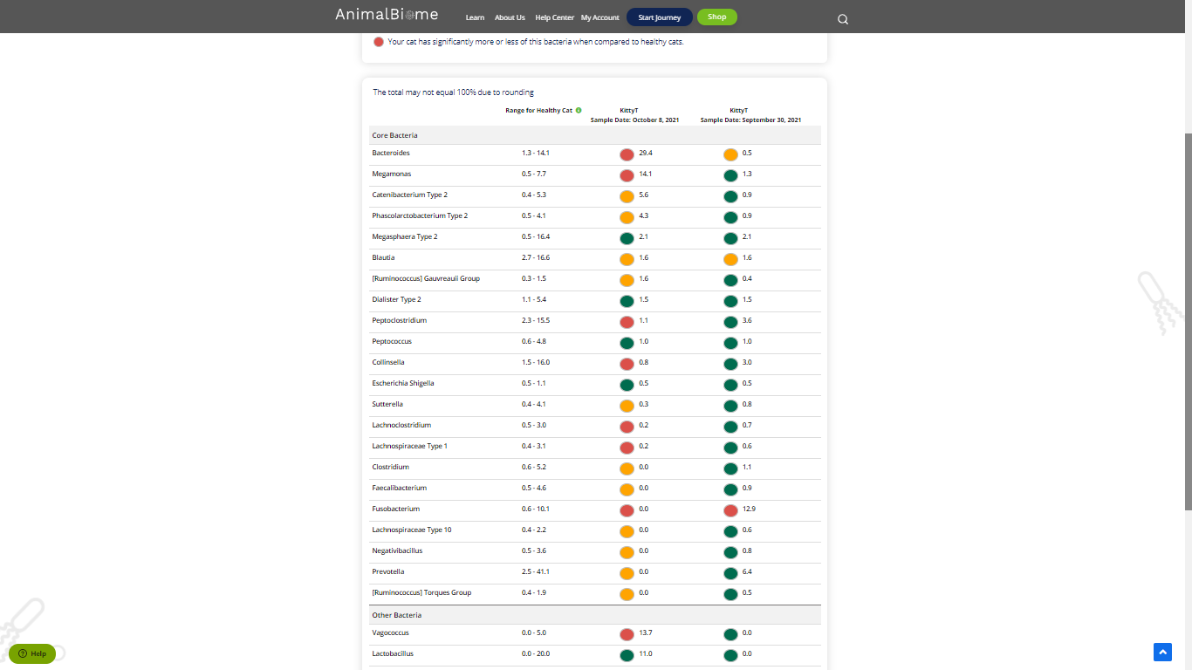

Low group evaluation:

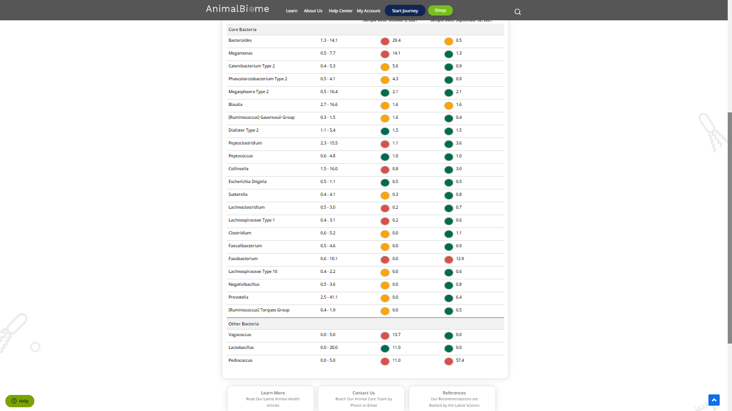

Low red blautia : failed.

Low red bacteroides : failed (1 condition satisfied ) in the primary group.

Total yellow flags : 11

Red flags : 9

The result : **False True True**

Moderate to severe results:Pass

Expected result : **Moderate to severe**

Achieved result : **passed.**

